This is a board to adapt a 2.4Ghz NiceRF SX1280 LoRa module into a breadboard friendly format. The board will allow you to use your SX1280 module with a standard 0.1” matrix breadboard or strip board. This is a board only, no SX1280 module is supplied.
The SX1280 module has the ability to measure distances between a pair of devices, one as master the other as slave. This ‘ranging’ ability works from a few tens of meters up to circa 850km, see here;
2.4Ghz NiceRF SX1280 LoRa® Balloon Tracker - 85km Achieved
The SX1280 module has edge connectors for an SMA or u.FL connector. Alternatively a simple bit of wire 3.15cm long will do. The boards are supplied with the 0.1" pins unsoldered, leaving you the option of how to assemble or use the board in a project.
This board can be used with the Easy mikroBUS™ Pro Mini controller available in this shop.

The NiceRF SX1280 is a 3.3V supply and 3.3V logic level device, do not use directly with 5V controller boards such as the Arduino UNO.
The pinout of the board is below, the module pins on the outside.

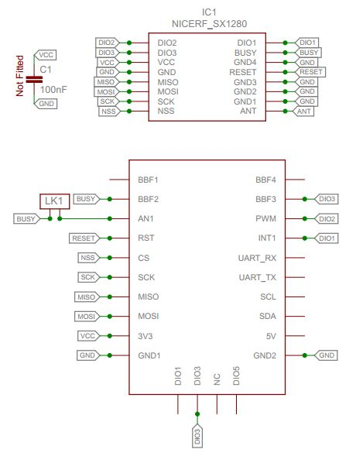

There are many examples for using these boards for GPS trackers or sensors provided in an Arduino the library here; https://github.com/StuartsProjects/SX12XX-LoRa

